Logo%20Main%20200

**Boston University**

**Electrical & Computer Engineering**

**EC464 Senior Design Project**

User's Manual

Efficient Solar Panels with Water

Submitted to

Professor Robert Kotiuga

8 St. Mary’s St Boston, MA

02215, Room 523

(617)-353-4151

prk@bu.edu

by

Team #21

Team Solar Panels

Team Members

Hal Levin [hlevin3@bu.edu](mailto:hlevin3@bu.edu)

Moises Bensadon [moises@bu.edu](mailto:moises@bu.edu)

Stanley Nguyen [stanguye@bu.edu](mailto:stanguye@bu.edu)

Submitted: 17 April 2023

#### Efficient Solar Panel User Manual

#### Table of Contents

Executive Summary 2

1. Introduction 3

2. System Overview and Installation 6

3. Operation of the Project 10

4. Technical Background 11

5. Cost Breakdown 12

6. Appendices 13

6.1 Appendix A – Specifications 13

6.2 Appendix B – Team Information 13

# Executive Summary

Solar Panels average between 20% - 30% efficiency which decreases when temperatures get too high. Although it may be the sunniest day out, this drop in efficiency means hot sunny days produce less energy than cooler less sunny days. By adding a cooling process with water to existing solar panels, we can increase efficiency and extend the cell’s life. We can also use the waste heat from the solar panel to begin heating water for residential use. This can then be used in conjunction with a solar water heater, which has an efficiency of approximately 80%. Our system would be built and implemented with residential household electrical and piping systems. A smart monitoring system will be designed in such a way that it would be flexible and sufficient for a majority of houses. This is a heavy build project; requiring a mixture of electrical and plumbing skill sets to achieve a successful renewable energy system. The nature of the project will require modifications and/or changes to current or future designs in homes. By collecting data at different temperatures using our prototype, we can quantitatively show the energy and cost savings that our product can provide for the user.

# Introduction

Our purpose in this project is to research and design a system to fulfill the needs of our client. Our client, Professor Kotiuga from Boston University, proposed a systematic improvement to current solar panel systems used in commercial and residential buildings. The inspiration behind Professor Kotigua’s idea is that solar panels can increase power production if they’re cooled down to an ideal temperature. Current solar panels are around 15%-22% efficient when operated under optimal conditions. At very hot temperatures, the efficiency and power output of the solar cells can decrease by a reasonable amount.

Our client has a vision for his project and is looking for a system that can increase the efficiency of photovoltaics without compromising too much energy. With basic laws of energy, we know that cooling such a system will come at an energy cost. The approach to our system will be to research a way of cooling the panels while having the increased efficiency be greater than the amount of energy needed to operate the system. Our client will be working with us in the design and manufacturing of a new solar panel system that would integrate water cooling into the system with the feature of being able to use heated water as per usual in current buildings.

Our goal is to increase solar panels' efficiency by using the cold water pumped out of water tanks or from a separate pipeline. A few crucial parts of the design we will have to look out for include pipe diameter, water pump flow rate, and materials that have a high heat transfer coefficient. Our team has already constructed a minimum viable product that allows cold water to flow through the solar panel while the solar power can absorb solar energy and charge a small car battery. So now we will be analyzing and tracking cell temperature vs. power production to determine what the ideal temperature for maximum power efficiency would be. The cold water will ideally come from the exit tube of the home’s water heater since this already exists in most homes and wouldn’t require additional power dedicated to cooling the water.

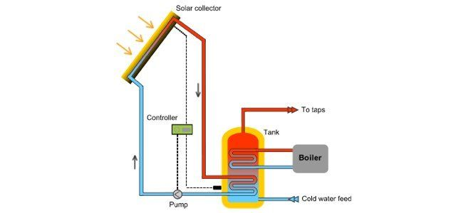

*Figure 1: A basic layout of how solar hot water systems work, our implementation would replace the solar connector with a photovoltaic*

With current climate change and rising temperatures, any improvement in the efficiency of energy generation is crucial and beneficial. Solar panels have been decreasing in price in the last couple of years but their efficiency hasn’t reached the levels of powering an entire home. Cooling solar panels can be a simple concept, but how can we do so in the most efficient way possible and create the least amount of waste?

Something that is used regularly in typical households is water from pipelines. This water comes in cold from the outside. We will need to engineer a way of efficiently circulating water through the panels and eventually back to water heaters already present in a home.

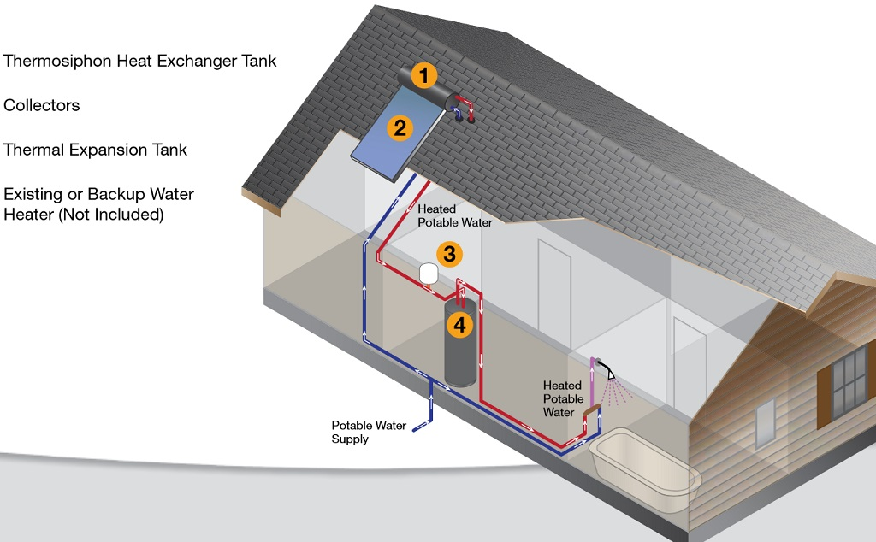

*Figure 2: How we envision our system to be implemented in an individual home setting. At point 1, water is stored and sensed. Once the system has decided it is time to circulate water, a pump between points 1 and 3 will be activated where warm water is moved into point 4, a water heater tank to be used in the future. Heated potable water will be heated with less energy with our system as warm water has been placed in the water heater from the solar panels.*

**Concept Development**

This system also has to be designed in a way that is appealing to users, and therefore we plan on creating an intuitive user dashboard for customers to view power production on a given day and the estimated increase in efficiency due to the cooling system. A possible reach goal that we could go for is implementing a system that would decide if it is more efficient to use the extra power gained to (a) power the water heater, (b) store it in batteries for future use, or (c) sell the energy back to the city grid. The reason behind these choices would be based on the time of year, the fact that batteries lose charge over time, and the price the city pays for electricity buybacks. Because most comparable products would come with rather advanced dashboards we aim to make the management portal very sleek and useful to the consumer. Possible ideas include connecting to the Internet to add local weather predictions and maybe even integrating with smart home protocols if time permits.

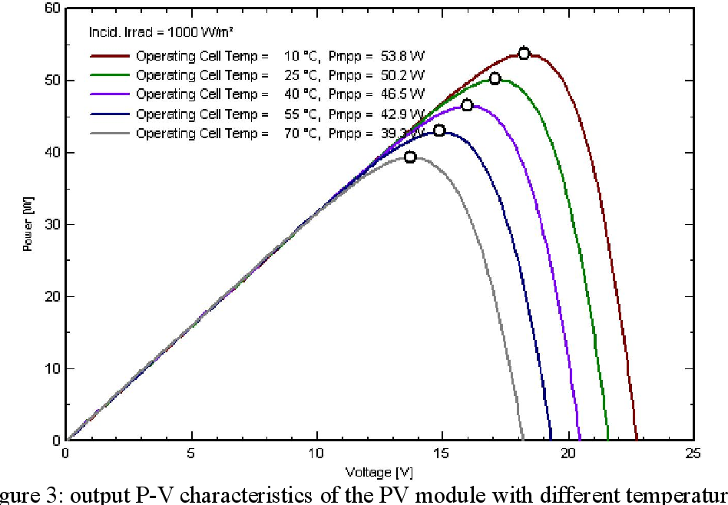

*Figure 3: Solar panels need to be at the right temperature to output maximum power for the same input.*

# System Overview and Installation

We need to ensure that solar panels will no longer reach temperatures where efficiency will begin to drop and become less efficient. The extra heat generated by the solar panels will heat our cooling water, which will be used as domestic hot water, reducing the energy that would have been used to heat water that is much colder.

A sufficient water pump will also be required for adequate water flow and pressure that is needed to achieve the cooling that is needed. This pump ideally would be as efficient as it can be while having enough torque. A choice between DC vs AC motors and pump was evaluated and chosen accordingly.

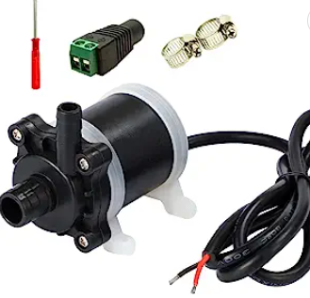

*Figure 4: Submersible 200 GPH 24W 12VDC water pump for our design.*

For the time being, we went with an aquarium-rated water pump, capable of 200 gallons/hour. The max power of this pump is rated at 24 watts. While this low-power water pump is a good choice for this application in terms of power consumption, pump power might be limited and will be tested for our final design. This water pump is a traditional pump that uses a DC input of 12VDC. During our prototype stage, we used a relay controlled by our microcontroller to switch on and off power from our battery, a 12VDC source. We were also able to achieve this by splicing the hot wire from the water pump and adding a relay, acting as a switch.

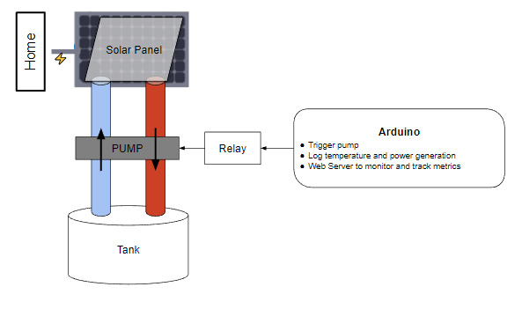

*Figure 5: Our prototype design of the solar hot water system with the water pump integrated into the system. This system for now will move hot and cold water beneath the solar panel.*

Temperature sensors will be used to ensure that we can monitor the temperature of the solar panels and water and let the system make automatic adjustments. We created a monitoring system that is able to record the temperature of solar panels and the water that it carries through a small thermistor. This device is part of the semiconductor family where it is able to act as a resistor that is sensitive to temperature, similar to the photovoltaics in our solar panels. Here, the measured value of a thermistor’s electrical resistance is directly correlated to the temperature of the environment in which the thermistor is put; this will mainly be hot or cold water temperatures.

From our Arduino, we can use its analog input to read the resistance of the thermistor to determine the temperature of the panel. Once we have a base case of resistance and its corresponding temperature, we can extrapolate that to determine if the solar panel temperature is too hot. Once the Arduino reads a resistance value that indicates a high temperature of the water, this information will be fed to the microcontroller where we can send a digital output of 5V to the relay signal pin to activate the switch.

The water pump will move cold water through the panel once this switch is activated. Enough water must be moved so that new, colder water is able to take place and effectively cool down the panel. If we move too much water, we are wasting extra energy by doing so, reducing the efficiency of the system. There will be a cold water source or water tank near the solar panel to ensure that we have enough cold water to cool the solar panel in case the cooling water is overheated, the solar panel's heat dissipation efficiency is low, and the energy conversion efficiency is reduced. We will measure how long it will take to fully circle one cycle of water through flow rate calculations and testing once we design our final product.

After the cooling water has absorbed enough heat from the solar panels, it will be transported to a warm water tank, where it may be heated by a heat pump used to cool the cooling water and piped to household use hot water. The heat pump will be powered by the electricity generated by the solar panels, which will trade for a higher energy conversion ratio than an electric water heater at a lower cost.

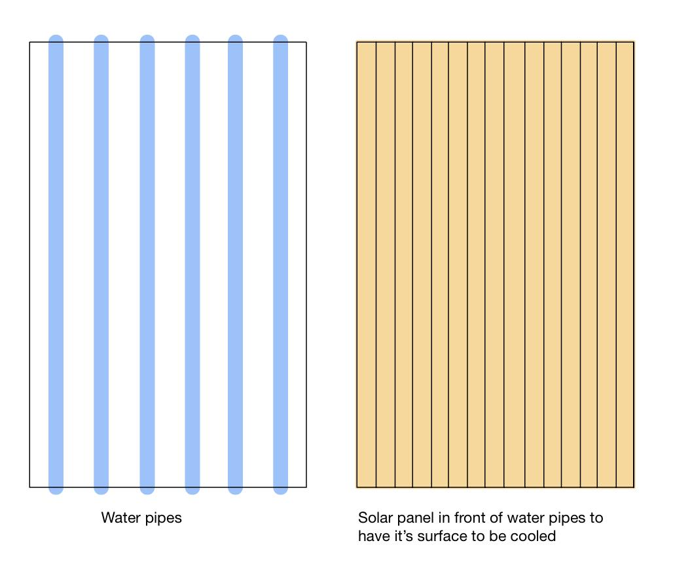

*Figure 9: Schematic diagram of the separated cooling/warming panel and solar panels.*

For installation, it would depend on the existing infrastructure in the user’s home. If they already have any of these components: solar panels, a heat pump, or a solar water heater, our product could be specifically made for their needs. For usage, the customer can view the dashboard that shows data collected over time for their panels. It displays current, voltage, and temperature vs time, and can show changes in power production.

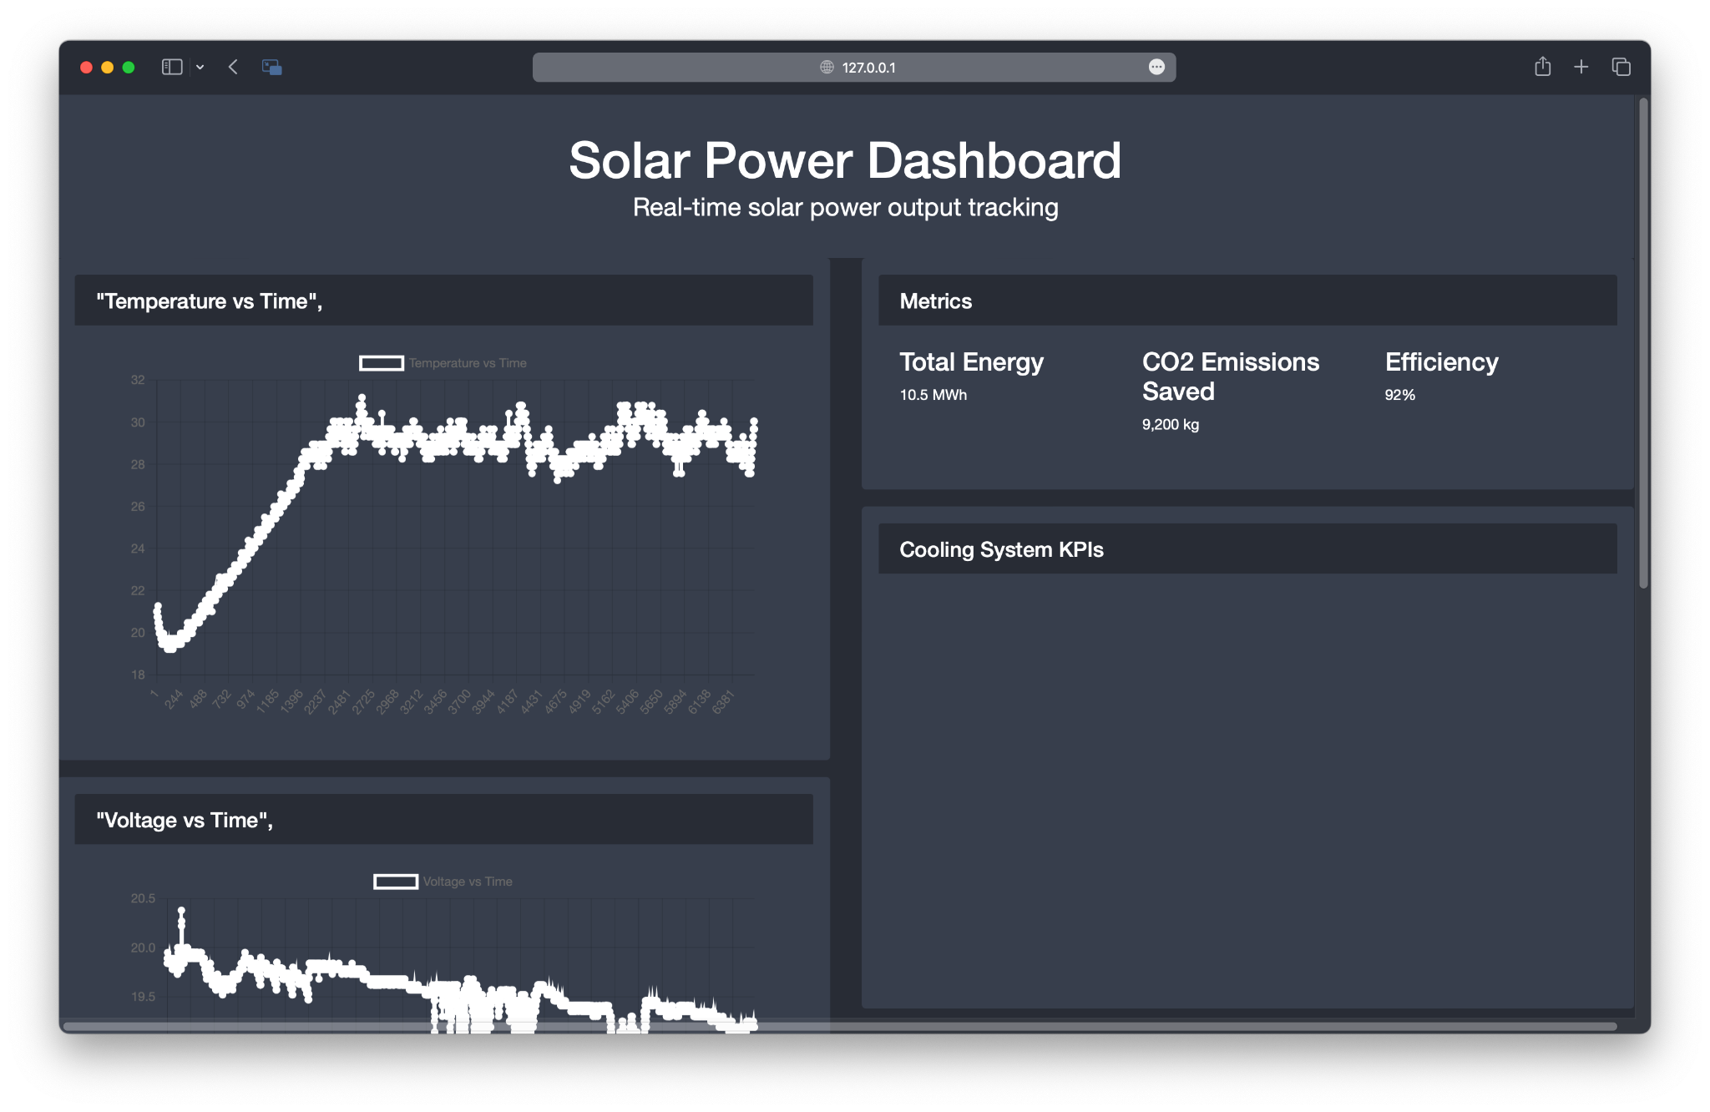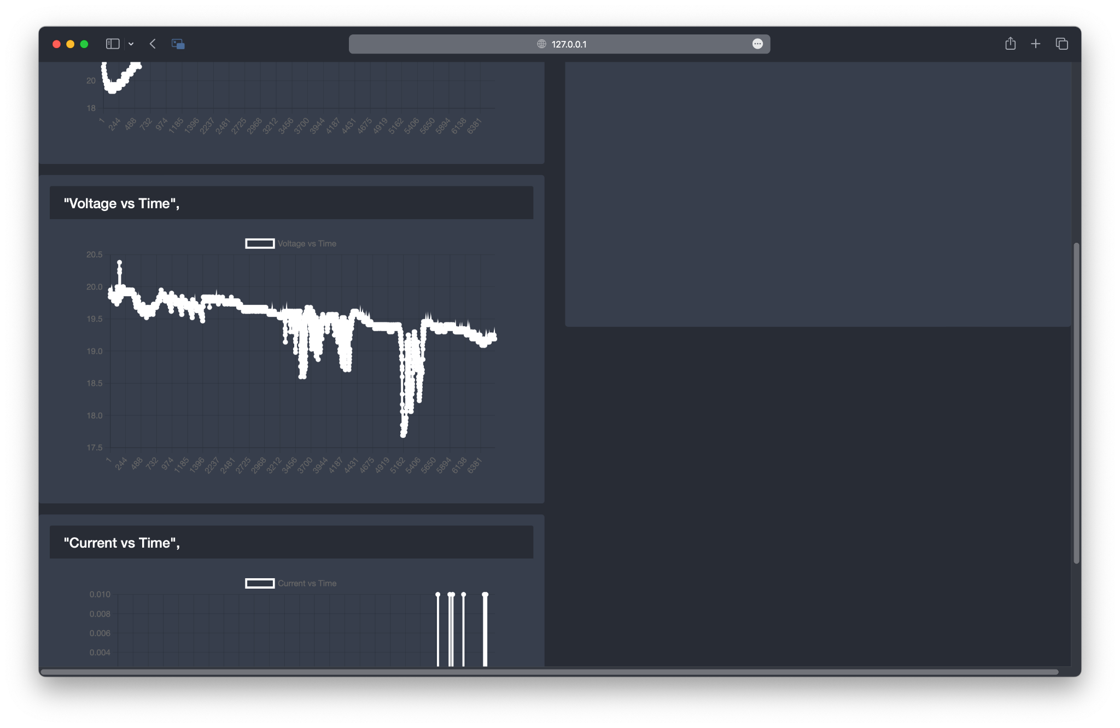

*Figure 10: Early Version of our User Dashboard Displaying temperature, voltage, and current vs time.*

From this dashboard, the user can view critical information about their panel’s energy production and how our product has positively affected it. The user may also see if over time the system does not work as well, meaning the product may need regular maintenance, specifically for the copper piping. The user also has the ability to forcibly turn on or off the water pump from the dashboard, overriding the automatic relay that turns the pump on at the predetermined threshold temperature.

# Operation of the Project

**Installation**

This product would be installed in a residential building. The customer would already have water flow and may or may not have solar water heating. Our product would be installed on the roof as a unit of solar panels with cooling units on the rear of them. The pipe input of the solar panels for cooling would be fitted to the water intake of the customer. The output of the pipes behind the solar panel would connect to the customer’s water heating system, either a heat pump and/or a solar water heater. The monitoring system and wiring for the monitoring system would be installed inside the customer’s house.

**Monitoring**

Through the monitoring system, the customer would be able to see the activity of our product, as well as its effect. The customer can view the efficiency increase as well as the energy and cost savings of this product. The customer can view the current outside temperature and the temperature at which the solar panels are automatically cooled. If the user wishes, they may also override the automatic cooling system and manually turn on or off the cooling. Through this monitoring system, the user may also be able to view any issues with the cooling system that may require physical maintenance.

**Abnormal Operation and Safety**

The user can view the energy production through the monitoring system. If the production has a significant drop when unexpected, there may be an issue with the product. This issue could be from the copper piping system, the water pump, the heat pump, or a sensor such as voltage, current, or temperature. Depending on how the monitoring system looks, an electrician or plumber can come to fix any issue that may arise. There is also a chance that the issue is directly with the monitoring system. A residential user should not try to fix the problem themselves due to safety concerns. If there is a leak of water, this increases the chance of an electric shock.

# Technical Background

Solar Panels are photovoltaic devices that can be simplified to a device called a PN junction diode. PN junction diodes are made of semiconductors, which have a complex response to temperature in relation to the current that is produced. PN junction diodes have an optimal operating temperature, because the efficiency increases with temperature to a certain extent, until a different factor becomes significant, making efficiency decrease with temperature increase. The physical explanation is that increasing the temperature increases the intrinsic carrier concentration in semiconductor materials. Higher temperature causes faster diffusion of carriers, meaning more collisions, leading to more recombinations. This means the saturation current increases, which acts like a shunt resistor when the current is high enough (at high temperatures) causing the open circuit voltage to decrease. Saturation current is the opposite of useful current in this device, the useful current is produced by light shining on the solar panel, through the photoelectric effect. The photoelectric effect causes light, which is made up of photons, to eject electrons of atomic orbitals, causing a flow of electrons, or current, when the photons have enough energy to do so.

# Cost Breakdown

| **Item** | **Description** | **Cost** |
| --- | --- | --- |
| 1 | Active Electric Components | $10 |
| 2 | Passive Electric Components | $10 |
| 3 | Arduino | $15 |
| 4 | Plastic Tubing | $10 |
| 5 | Solar Panel | $80 |
| 6 | Copper Piping(Vary by length and diameter) | $40 |
| 7 | Water Pump | $30 |
| 8 | Water Storage | $10 |
|  |  |  |
|  |  |  |
|  | Total Cost | $205 |

This is for one-panel installation where the user already has a heat pump as their water heater.

# Appendices

## Appendix A – Specifications

Team #21 Team Name: Efficient Solar Hot Water

Project Name: Efficient Solar Hot Water

| **Requirements** | **Value, range, tolerance, units** |
| --- | --- |
| Mount dimensions | 4 ft x 3 ft x 3 ft |
| Power | 12V DC |
| Water Pump | 200 Gallons/hour |
| Water Piping | Able to cool solar panel at least 15ºC |
| Dashboard | Display monetary savings, Power Usage, Amount of time spent cooling panel |

## Appendix B – Team Information

**Hal Levin**

Lead the more mechanical side of the design as well as some of the electrical components. Lead the physical housing of the solar panel, which is currently made of wood but may change material in the future. Lead the physical design of the piping behind the panel, and cut, sanded, and soldered the whole piping system. Part of leading the pump and tank orientations and also the electrical design and wiring.

**Moises Bensadon**

Focused on the control unit for our cooling system. Specifically, the logging of temperature, voltage, and current data and displaying it onto a web server. This is essential in determining the ideal temperature we wish for the solar panels to operate at. Additionally, the web server provides essential metrics to show users how much money they are saving or how much more efficient their solar panels are due to this cooling implementation. Planning on adding internet connectivity to possibly fetch local electricity costs and/or weather data to provide additional insights.

**Stanley Nguyen**

Contributed to the electric design and power flow of our system.